**ABSTRACT**

Being part of our college exquisite dance group (i.e Theme Ballet) we decided to develop a

Website, feeling that this might help future batches to more about ballet.

1) Number of viewers:

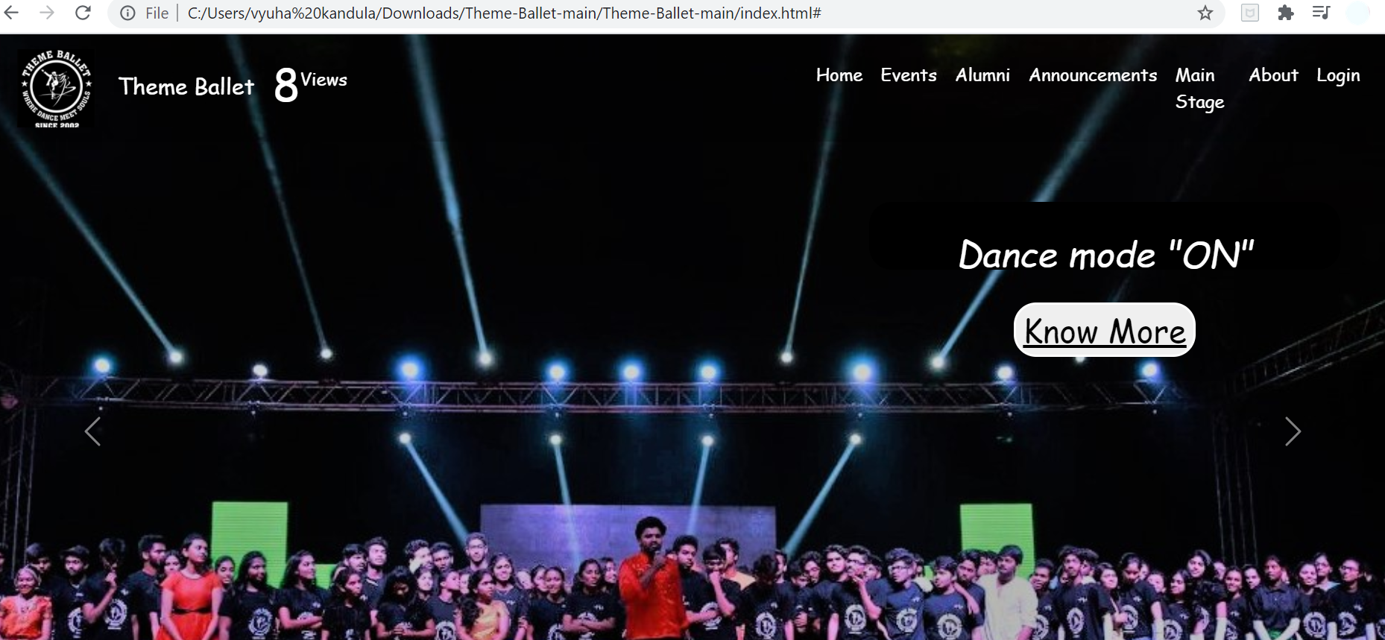

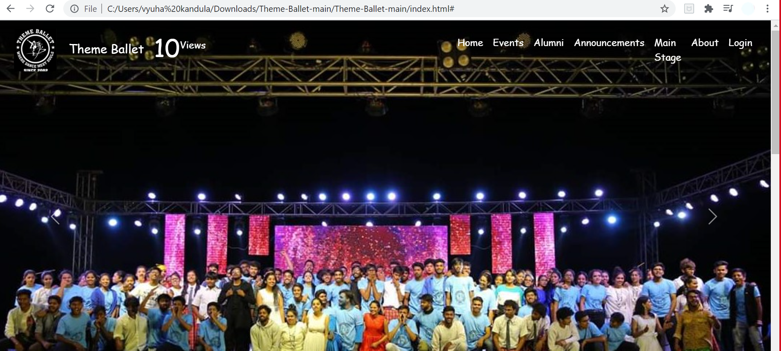

2)Added Admin Page: Admin page is created to manage users. The

co-ordinator handles this page.

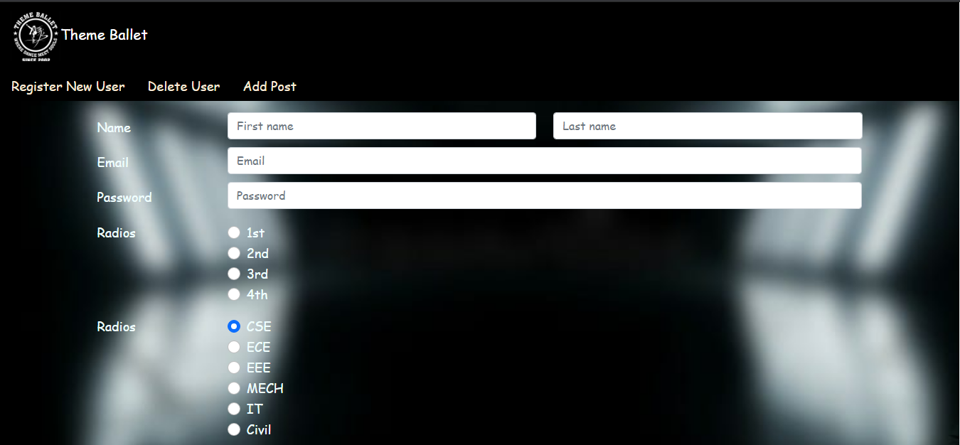

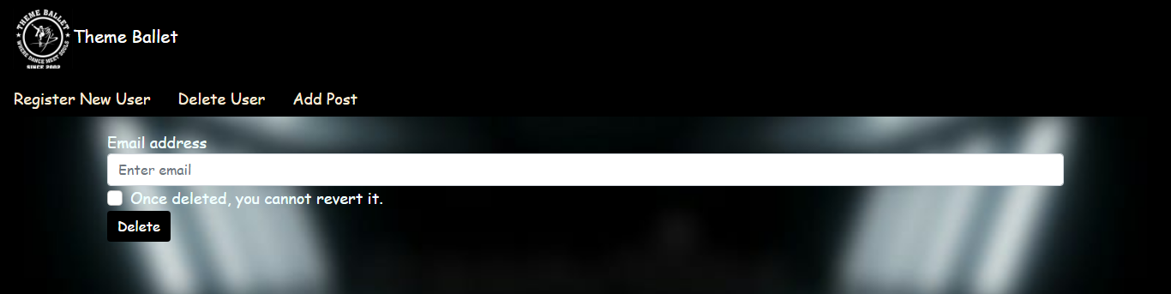

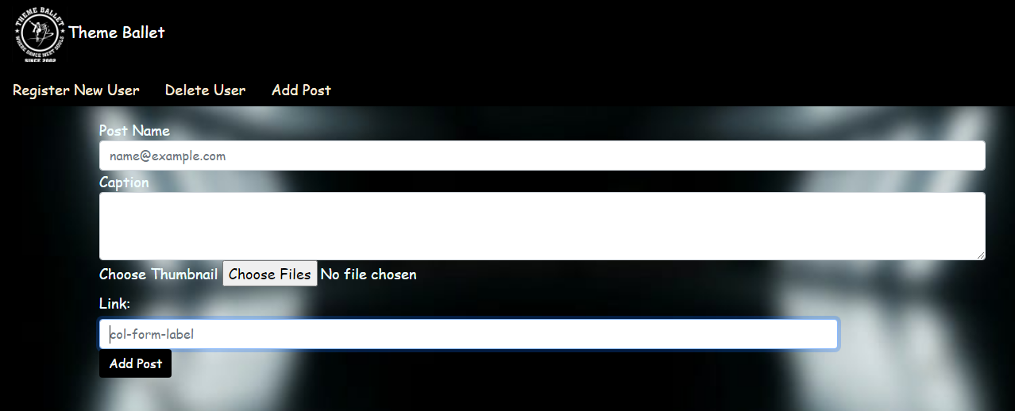

This web site contain details like:

1. Homepage (to give details about ballet i.e year it was formed, And why to choose Theme Ballet) 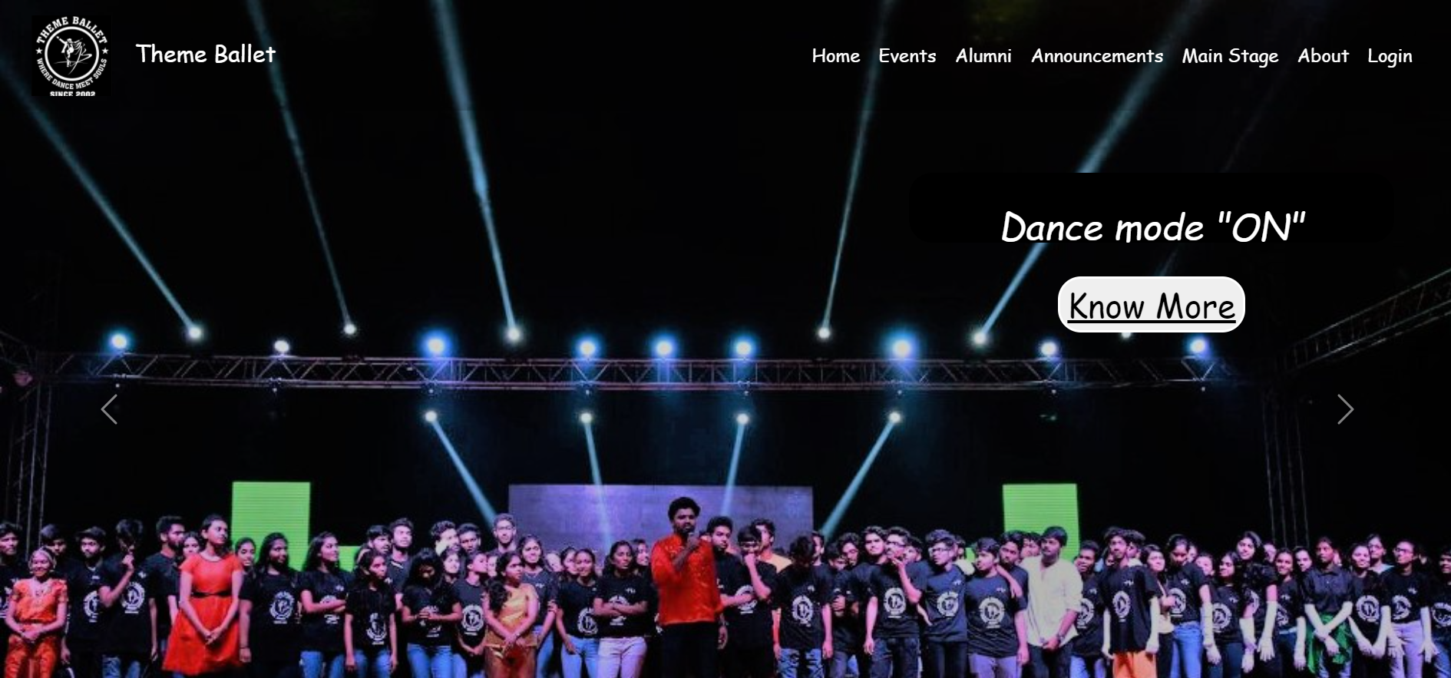
2. Alumni details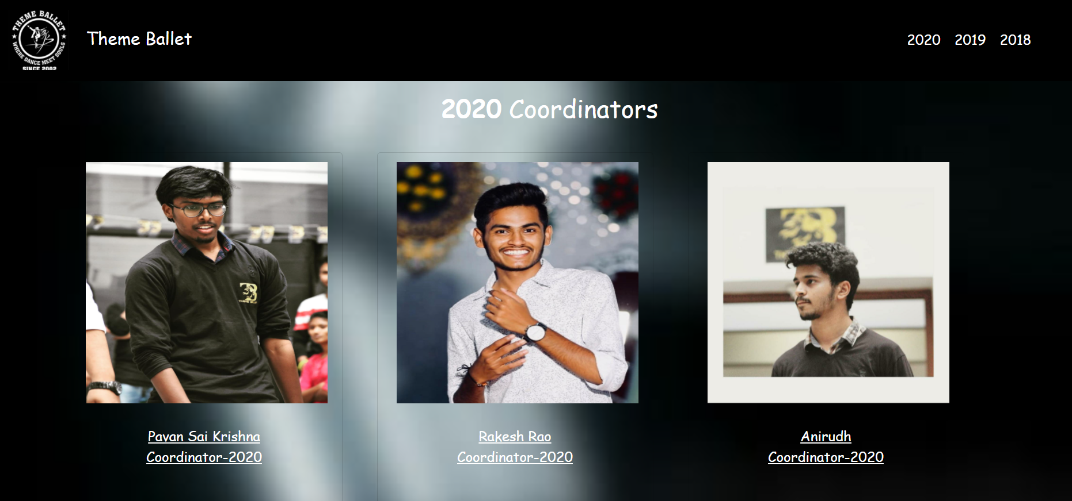
3. Previous year events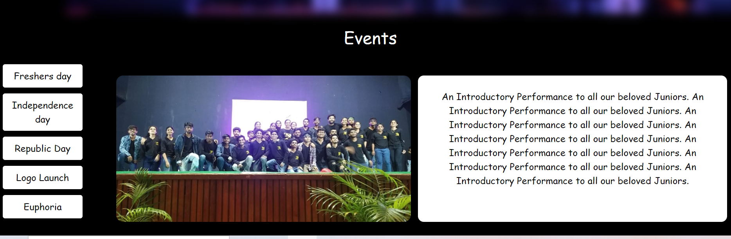
4. Main stage performance 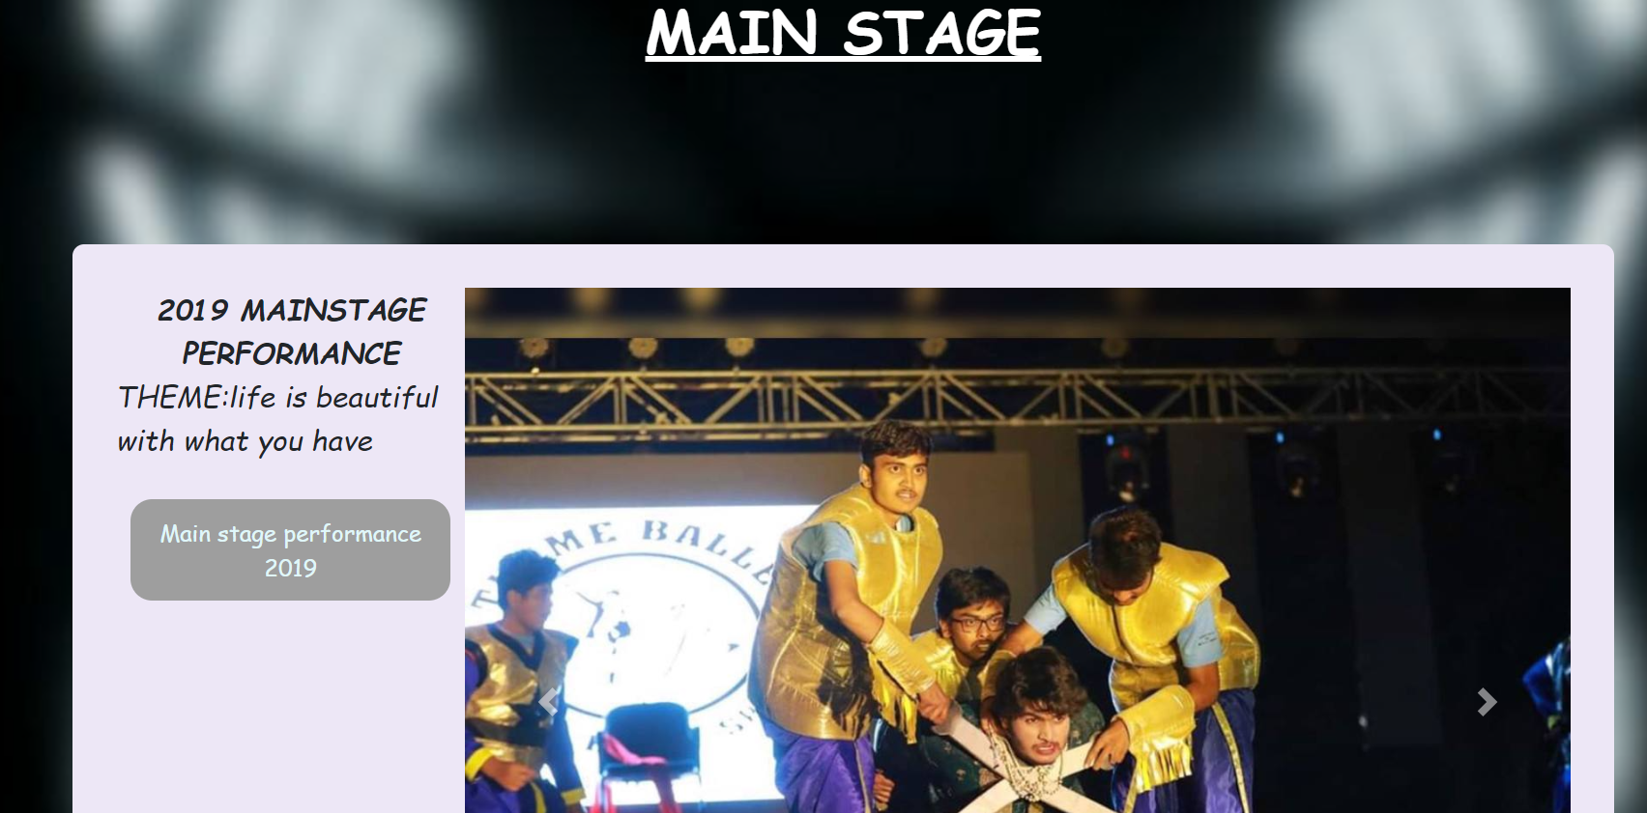
5. This help students to login and register for events to participate 